**PIZZA SALES SQL QUERIES**

**A.KPI’S**

**1.TOTAL REVENUE**

**select sum(total_price) as total_revenue from pizza_sales;**

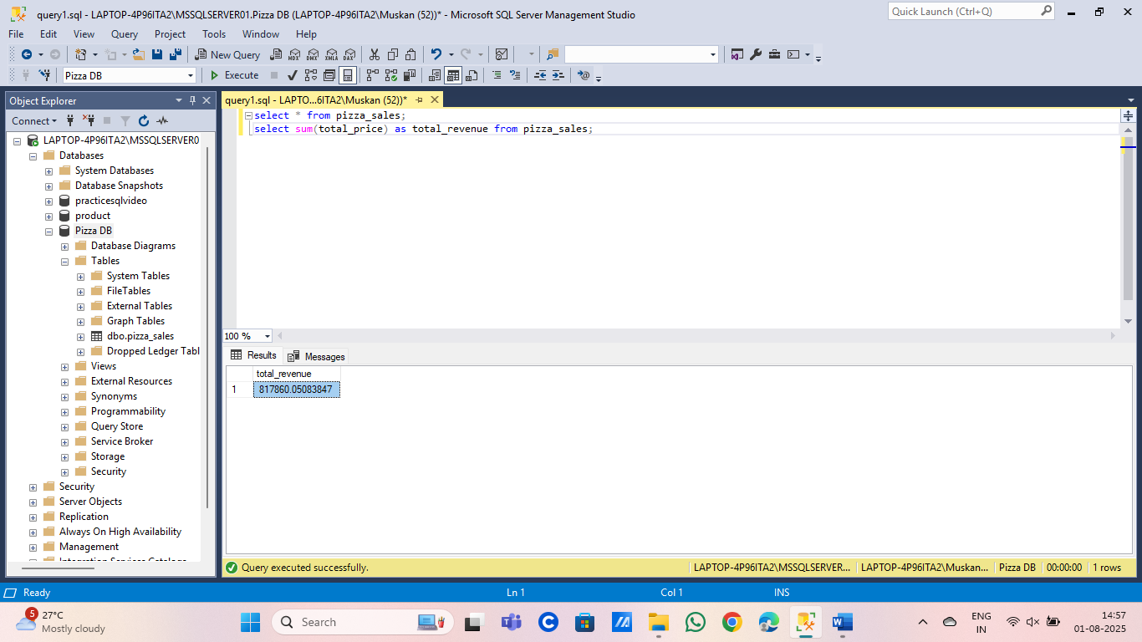

**2.AVERAGE ORDER VALUE( AVG AMOUNT SEPENT ON EACH ORDER):**

**select distinct sum(total_price) /count(distinct(order_id)) as avg_order_value from pizza_sales;**

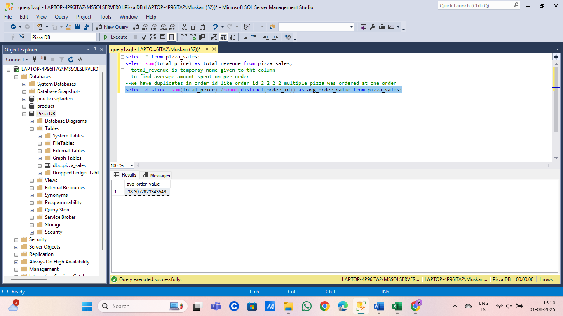

**3.TOTAL PIZZA SOLD:**

**select sum(quantity) as total_pizza_sold from pizza_sales;**

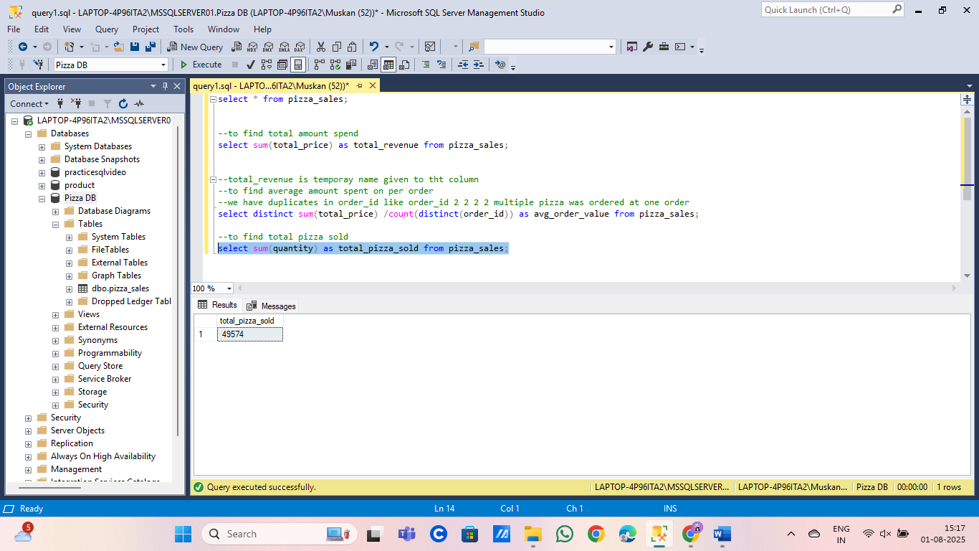

**4.TOTAL ORDERS:**

**select count(distinct(order_id)) as total_orders from pizza_sales;**

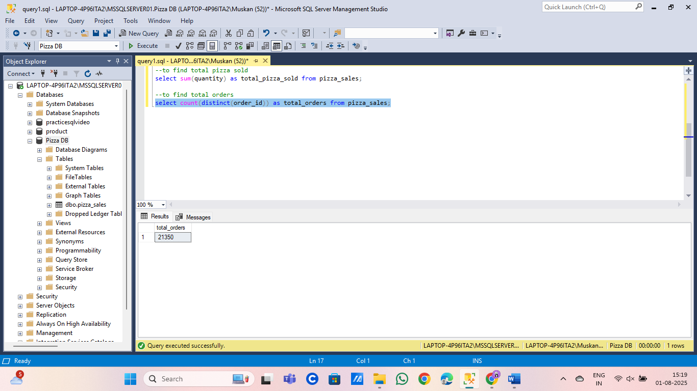

**5.AVERAGE PIZZA PER ORDER:**

**select cast(cast(sum(quantity) as decimal(10,2)) /cast(count(distinct order_id) as decimal(10,2)) as decimal(10,2)) as avg_pizza_per_order from pizza_sales;**

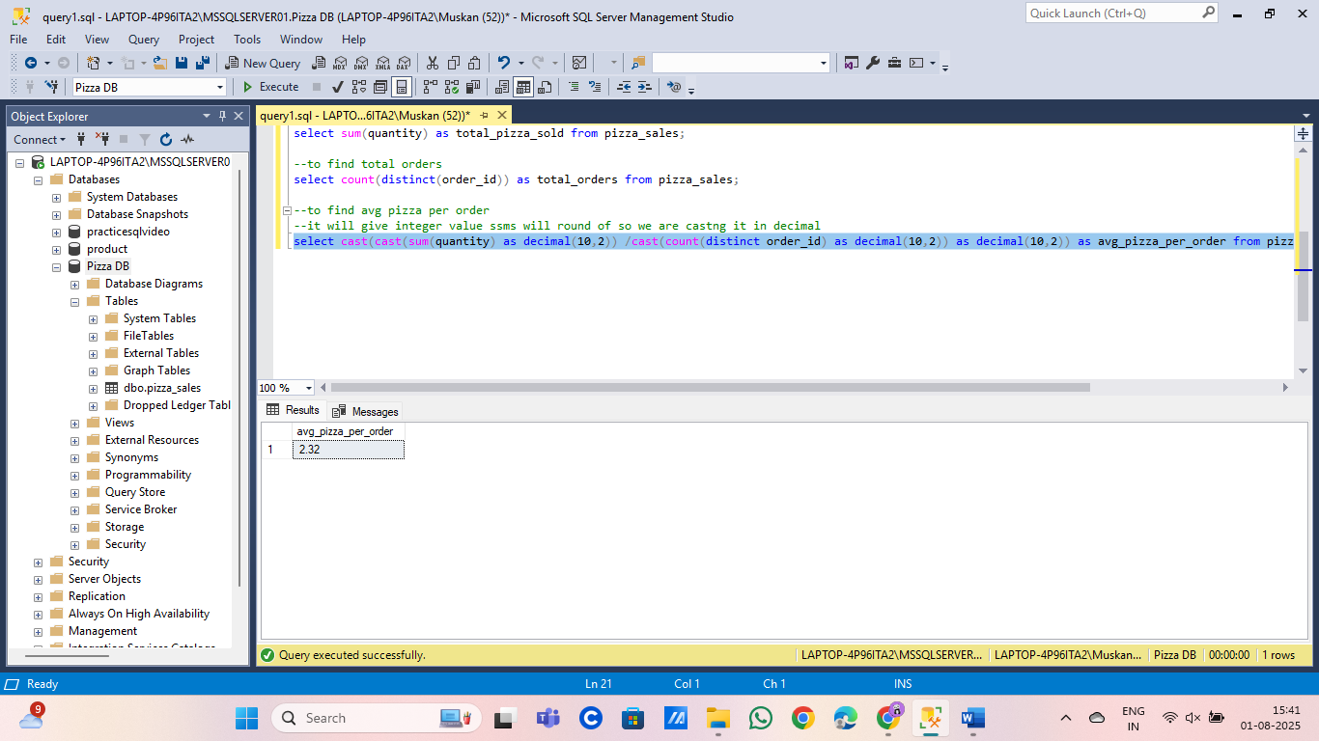

**CHARTS REQUIREMENT**

**1.DAILY TREND FOR TOTAL ORDER:**

**select DATENAME(dw,order_date)as order_day,count(distinct(order_id)) as total_orders from pizza_sales group by DATENAME(dw,order_date);**

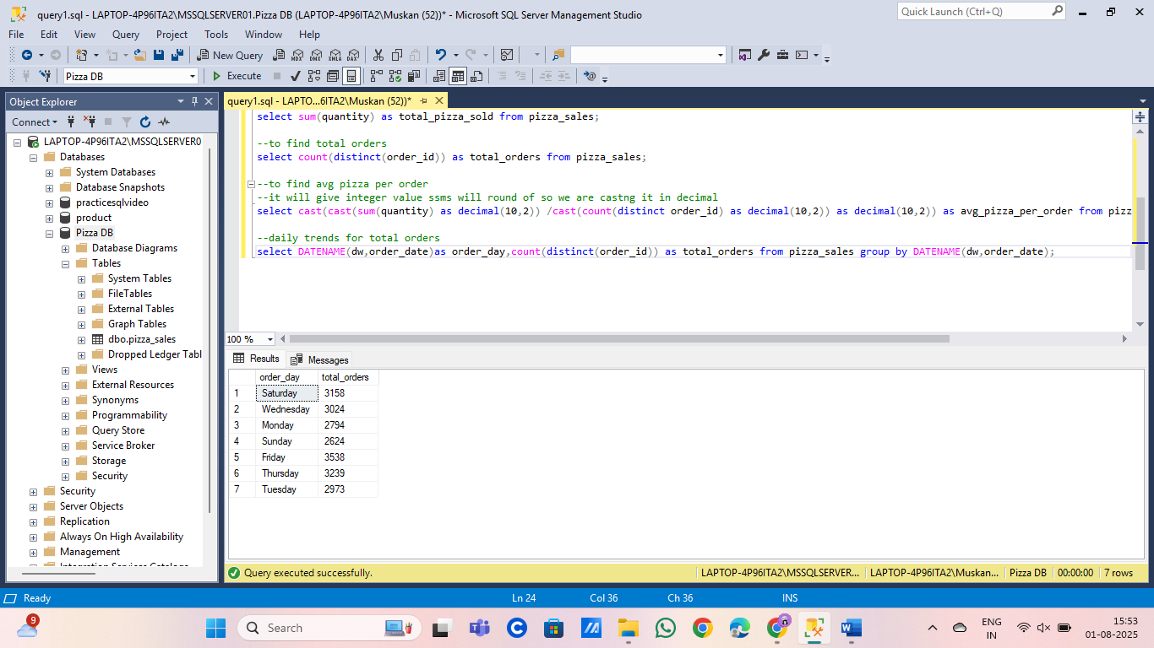

**2.MONTHLY TRENDS FOR TOTAL ORDERS:**

**select DATENAME(month,order_date) as month,count(distinct(order_id)) as total_orders from pizza_sales group by DATENAME(month,order_date);**

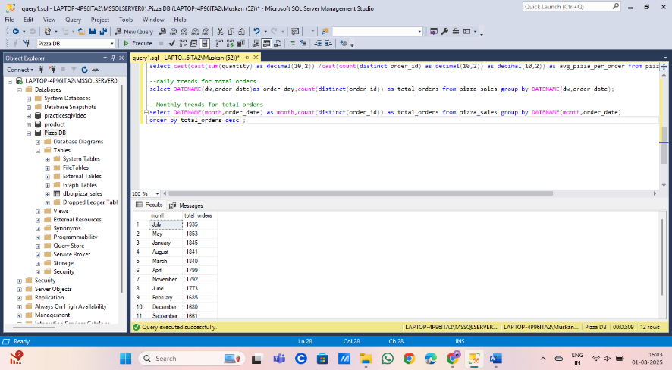

**3.PERCENTAGE OF SALES BY PIZZA CATEGORY:**

**select pizza_category,sum(total_price)*100/(select sum(total_price) from pizza_sales) as percent_total_sales from pizza_sales group by pizza_category;**

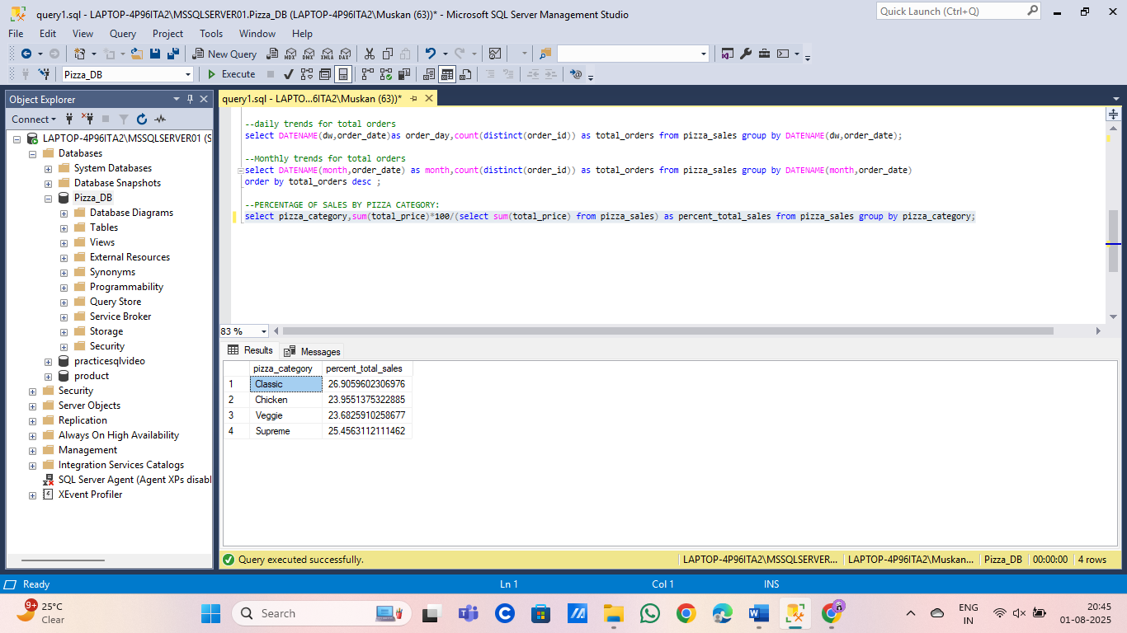

**NOTE:**

**For particular month:**

**For example january:**

**select pizza_category,sum(total_price)*100/(select sum(total_price) from pizza_sales where month(order_date)=1) as percent_total_sales from pizza_sales where month(order_date)=1 group by pizza_category;**

**4.PERCENTAGE OF SALES BY PIZZA SIZE**

**select pizza_size,cast(sum(total_price)*100/(select sum(total_price) from pizza_sales) as decimal(10,2))**

**as percent_total_sales from pizza_sales group by pizza_size order by percent_total_sales desc;**

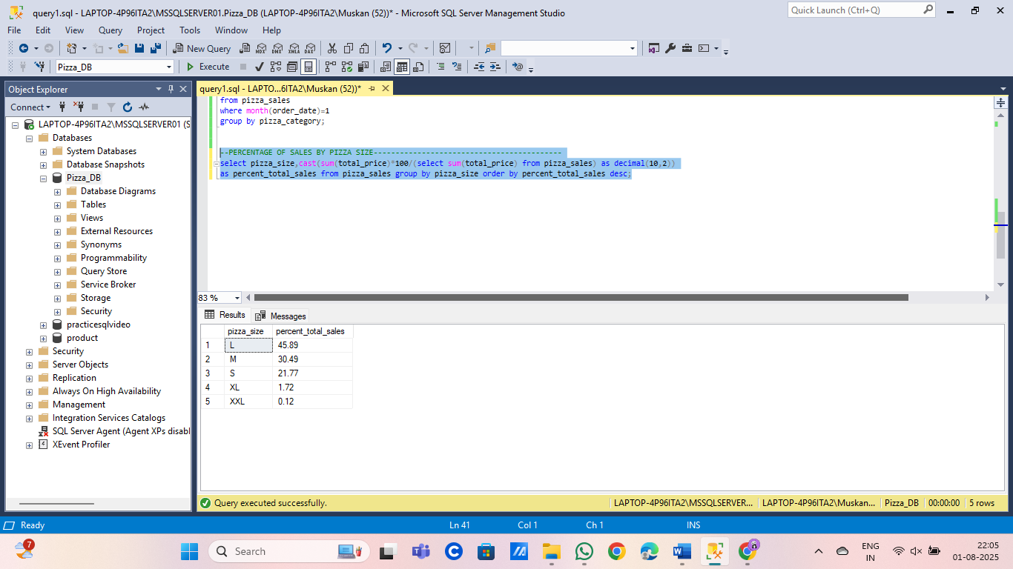

**for first quarter:**

**select pizza_size,cast(sum(total_price) as decimal(10,2))as total_sales,cast(sum(total_price)*100/(select sum(total_price) from pizza_sales**

**where datepart(quarter,order_date)=1)**

**as decimal(10,2))**

**as percent_total_sales from pizza_sales where datepart(quarter,order_date)=1**

**group by pizza_size order by percent_total_sales desc;**

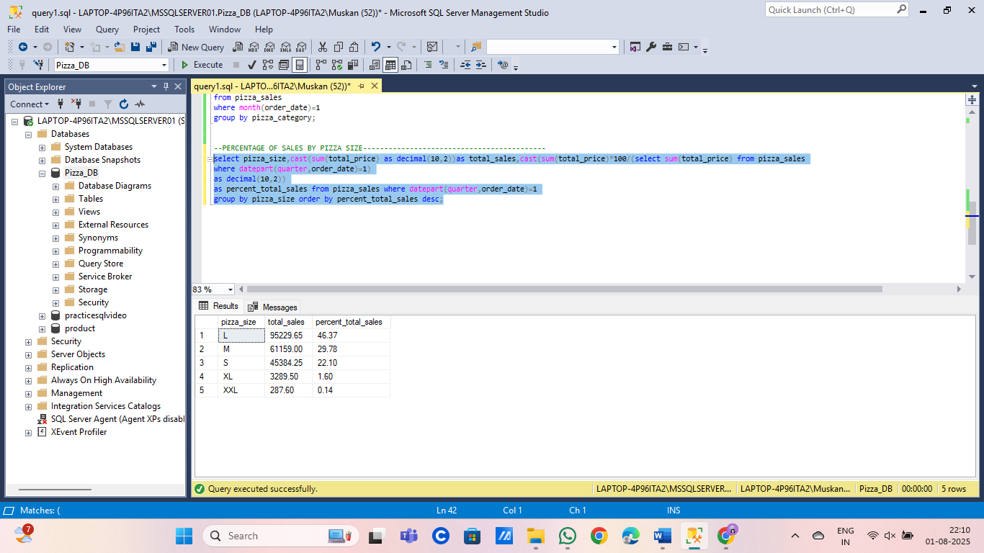

**5.TOP 5 BEST SELLERS BY REVENUE,TOTAL QAULITY,TOTAL ORDERS**

**A.TOP 5 BEST SELLERS BY REVENUE:**

**select top 5 pizza_name,sum(total_price) as total_revenue from pizza_sales group by pizza_name order by total_revenue desc;**

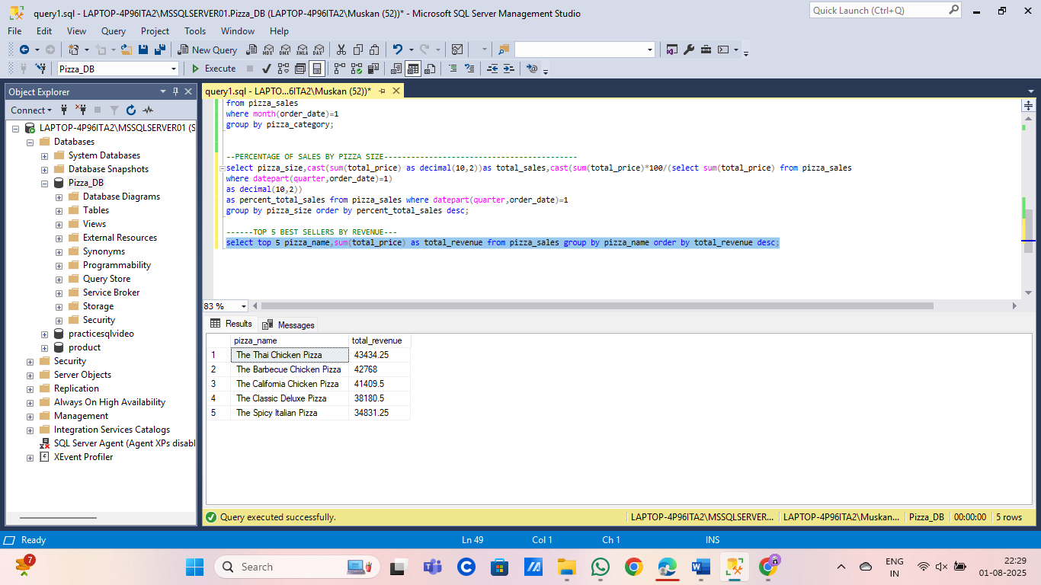

**b.TOP 5 BEST SELLERS BY TOTAL QAULITY:**

**select top 5 pizza_name,sum(quantity) as total_quantity from pizza_sales group by pizza_name order by total_quantity desc;**

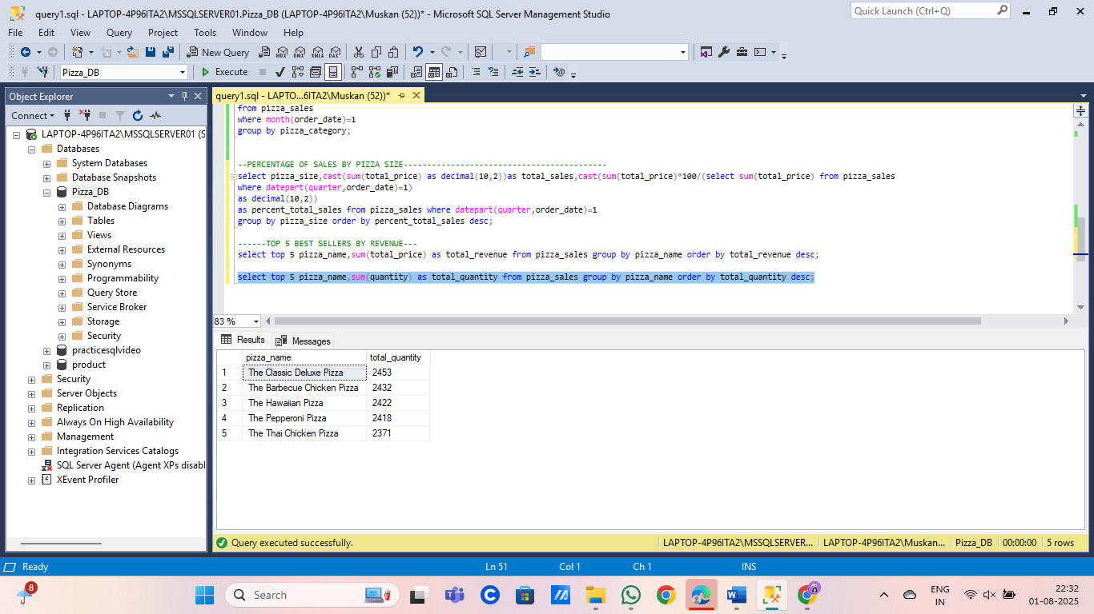

**C.TOP 5 BEST SELLERS BY TOTAL ORDERS:**

**Select pizza_name,count(distinct(order_id)) as total_orders from pizza_sales group by pizza_name order by total_orders desc;**

